New partners, research results, and addition of AI tools
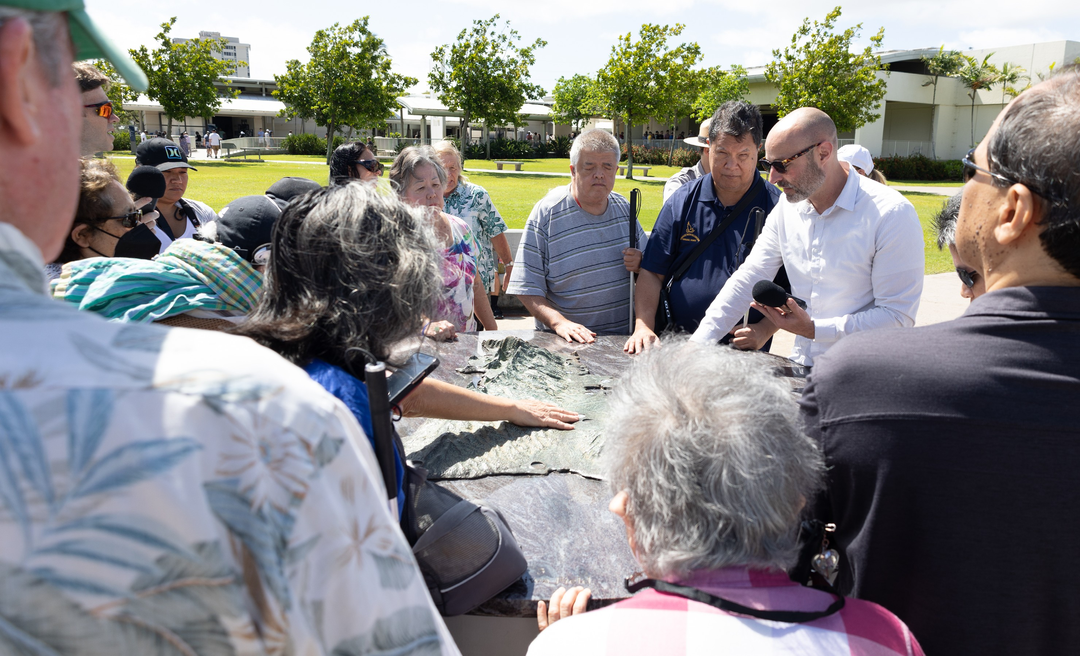

With Covid-19 pandemic restrictions finally fading this year, UniD researchers were back into the field doing extensive studies at two national parks: Pearl Harbor National Memorial in Honolulu, HI,
and Pullman National Historical Park in Chicago, IL.
We also completed another major Descriptathon workshop, our ninth, which was our largest to date, with more than 150 people participating from around the U.S., in Canada, and in the United Kingdom. They were a part of 16 teams
in the friendly competition designed to improve accessibility worldwide.
We shared at academic conferences and through scholarly publishing much new empirical work, and, in a sign of the times, we also have integrated our first AI (Artificial Intelligence) tool in our UniD software, with two other related AI tools under development as well and planned for release before Descriptathon 10, scheduled for February 2024.
We welcomed many new partners to our initiative, too, including our first state park and several other organizations that independently used UniD tools.

PHOTO: Hawaii Association of the Blind members listening to Audio Description of a tactile model at Pearl Harbor.
DESCRIBING: A horizontal photograph, the centerpiece visual on the page
DESCRIPTION: About 20 Hawaii Association of the Blind members came to Pearl Harbor National Memorial in April 2023 to help the UniD team study description of tactile models on site. This image shows a group of those HAB members listening to the descriptions while gathered around an outdoor tactile map of Oahu.

Highlights from July 2022 to June 2023, including D9

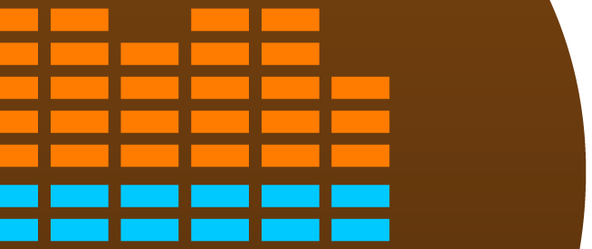
- D9, aka Descriptathon 9 featured teams from 16 public places: UniD’s latest workshop, in September 2022,
Report
The UniDescription
June 2023
welcomed and helped to make more-accessible: Agate Fossil Beds National Monument (Nebraska),
Aquarium of the Pacific (California), Big Thicket National Preserve (Texas), Bighorn Canyon National Recreation Area (Montana), Brooklyn Botanic Garden (New York), Bryce Canyon National Park (Utah), Cape Breton Highlands National Park (Nova Scotia, Canada), Fort Union Trading Post National Historic Site (Missouri), George Washington
Carver National Monument (Missouri), Great Basin National Park (Nevada), Lewis and Clark National Historical Trail (Pennsylvania, Illinois, Missouri, Kansas, Iowa, Nebraska, South Dakota, North Dakota, Montana, Idaho, Oregon and Washington), Mount Rushmore National Monument (South Dakota), Pahranagat National Wildlife Refuge (Nevada), Pullman National Monument (Illinois), Sequoia
and Kings Canyon National Parks (California), and Zion National Park (Utah)
- Two Major Grants Earned: UniD
was awarded two more significant grants for our work in 2023-2024: A
$55,000 grant from the U.S. National Park Service, and a $25,000 grant from Google.
- Publishing Research: Dr. Oppegaard and other UniD research collaborators published findings in several new and prominent venues this year, including in The Journal of Visual Impairment & Blindness, and Perspectives as
well as in conferences, such as the Interagency Accessibility Forum in Washington, D.C., and the Advanced Research Seminar on Audio Description in Barcelona, Spain.

